# Aryan Sai Venkat 230701040

# CSE A

EXP NO:8 PRODUCER CONSUMER USING SEMAPHORES

## PROGRAM

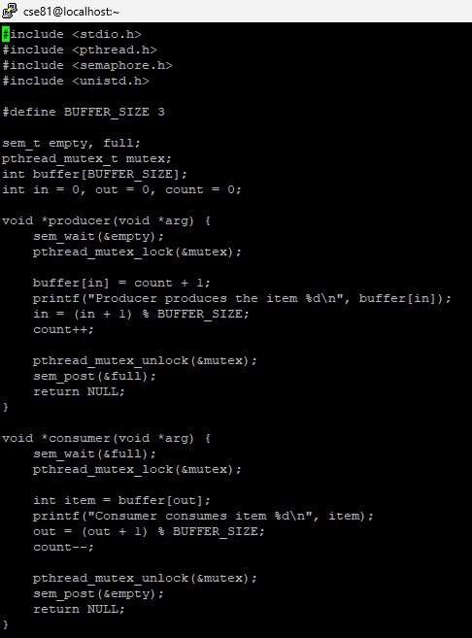

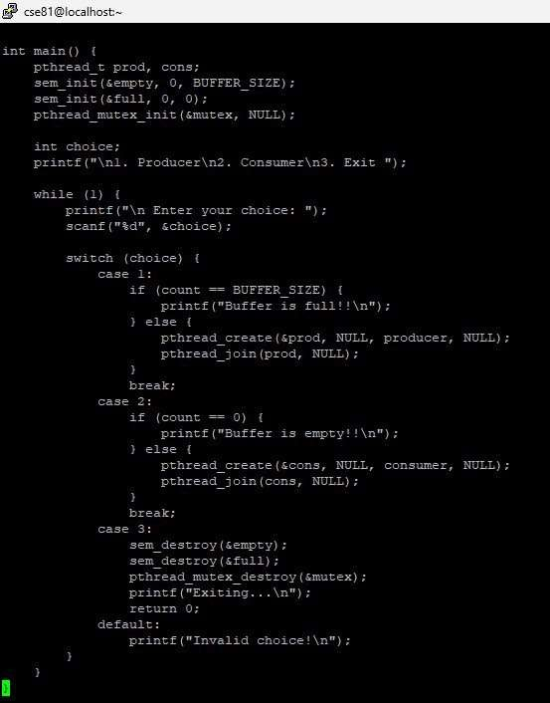

## OUTPUT

